**System and Software Architecture Description (SSAD)**

**Pic Share App (RA)**

**Team 1**

**Logan Chang – Project Manager, Developer**

**Jason Ard – Assistant Project Manager, Developer**

**Zhou Jiashun – System Integrator**

**Yew Hua Chua – Developer**

**Haihao Lu – Developer**

**Yunwei Yuan – Developer**

**Yao Wang – Developer**

**Weili Zhang – Developer**

**Lawrence Stratton - Developer**

**7 December 2015**

**Table of Contents**

1. Domain Model & Use Case Diagram 3

1.1 Domain Model 3

1.2 Use Case Diagram 4

2. Robustness Diagram 5

2.1 Navigation Robustness Diagram 5

2.2 Event Robustness Diagrams 6

2.3 Photo Management Robustness Diagram 9

2.4 Search Robustness Diagram 14

2.5 Profile Robustness Diagram 15

2.6 System & Administrator Robustness Diagram 17

3. Class diagram 19

4. Sequence Diagrams 20

4.1 Navigation Sequence Diagram 20

4.2 Event Sequence Diagram 20

4.3 Photo Sequence Diagram 24

4.4 Search Sequence Diagram 27

4.5 Profile Sequence Diagram 29

4.6 System & Administrator Sequence Diagram 31

# Domain Model & Use Case Diagram

## Domain Model

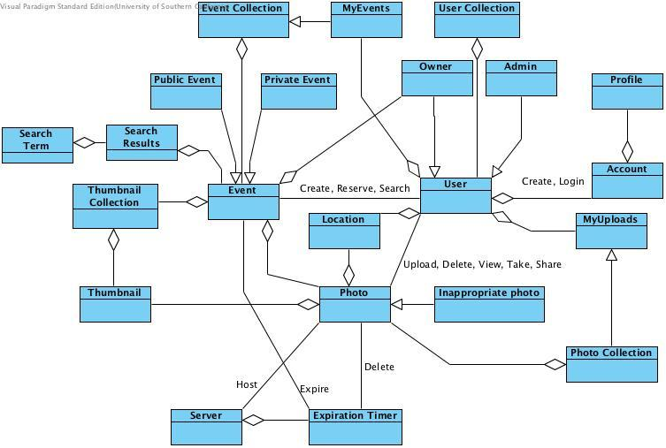

## Use Case Diagram

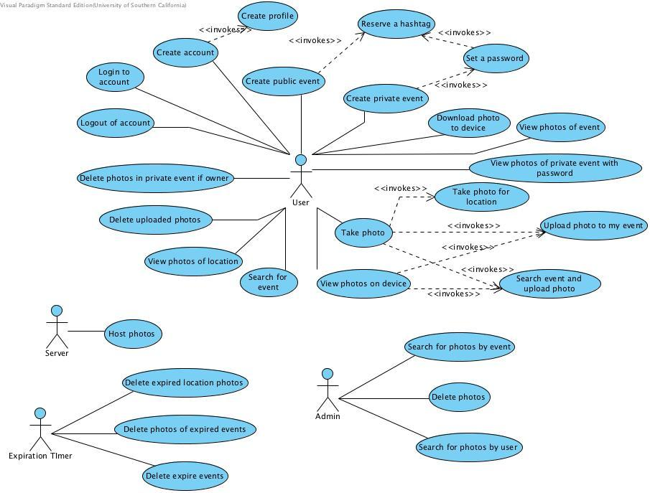

# Robustness Diagram

## Navigation Robustness Diagram

**Use Case: Navigation**

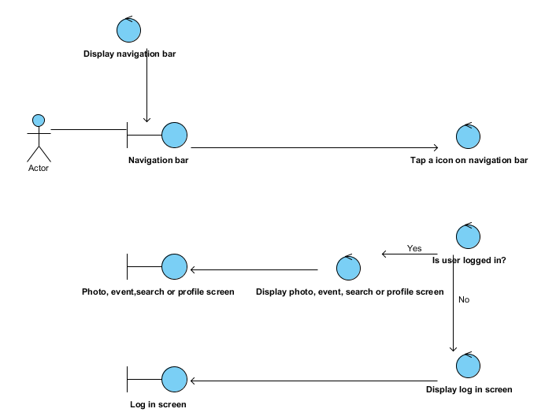

## Event Robustness Diagrams

**Use Case: Create a public event**

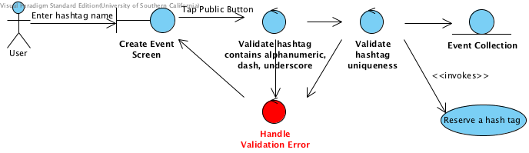

**Use Case:** **Create a Private Event**

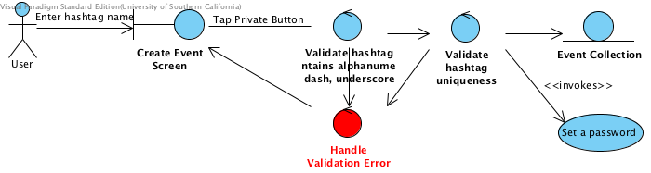

**Use Case:** **Set a Password**

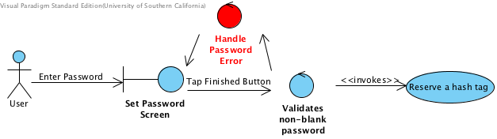

**Use Case:** **Reserve a Hashtag**

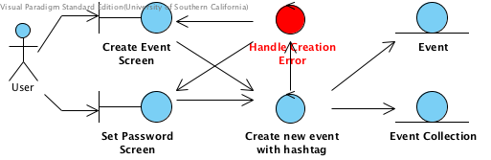

**Use Case:** **View photos of event/View photos of private event with password**

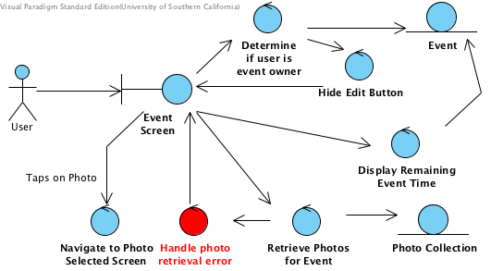

**Use Case: Download Photos to Device**

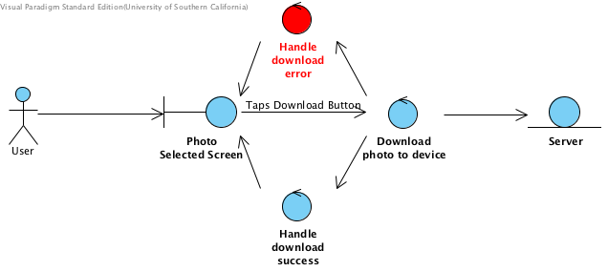

**Use Case: Delete Photos in Event if Owner**

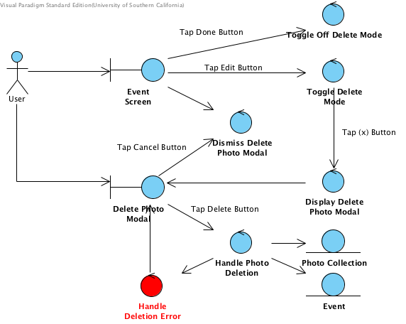

## Photo Management Robustness Diagram

**Use Case: Take a photo**

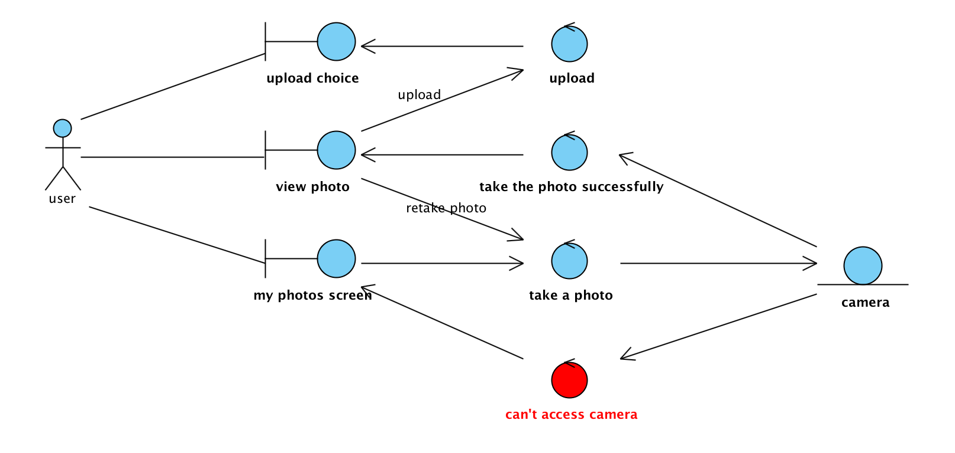

**Use Case: View photos on device**

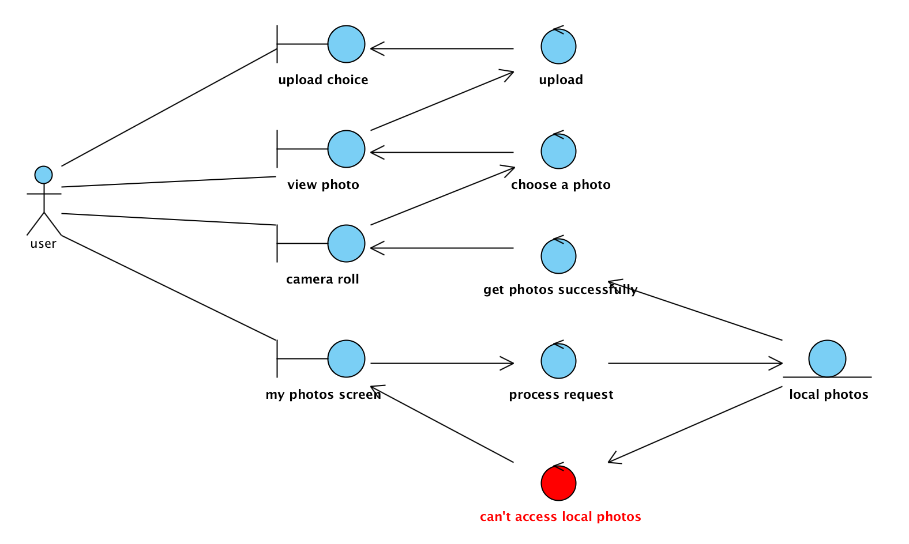

**Use Case: Upload photo to my event**

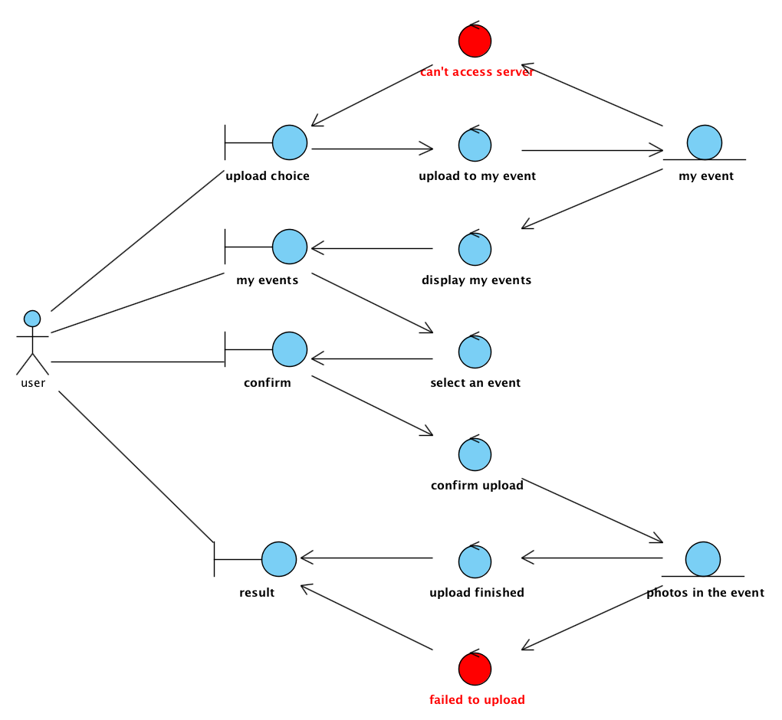

**Use Case: Search event and upload photo**

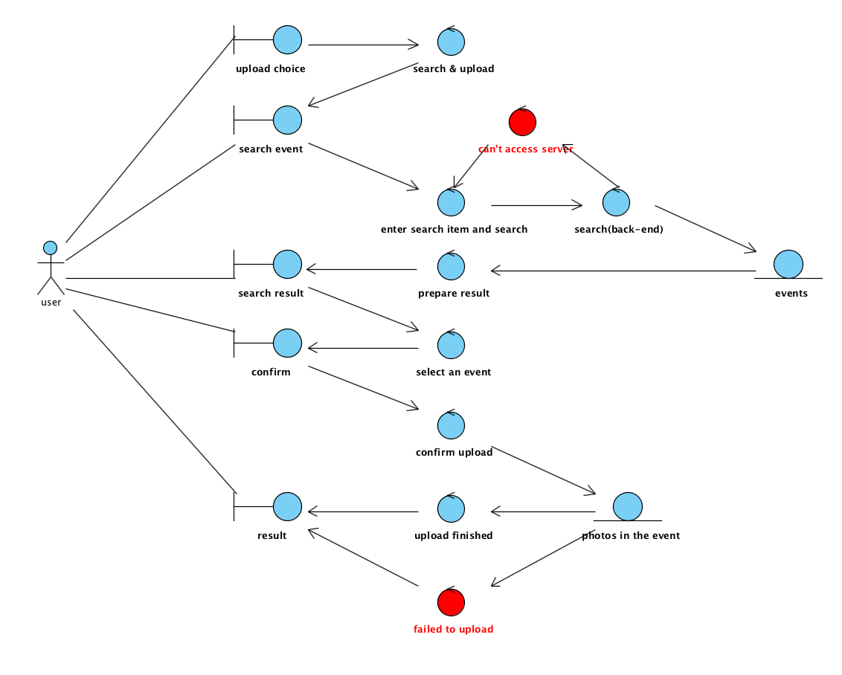

**Use Case: Take photo for location**

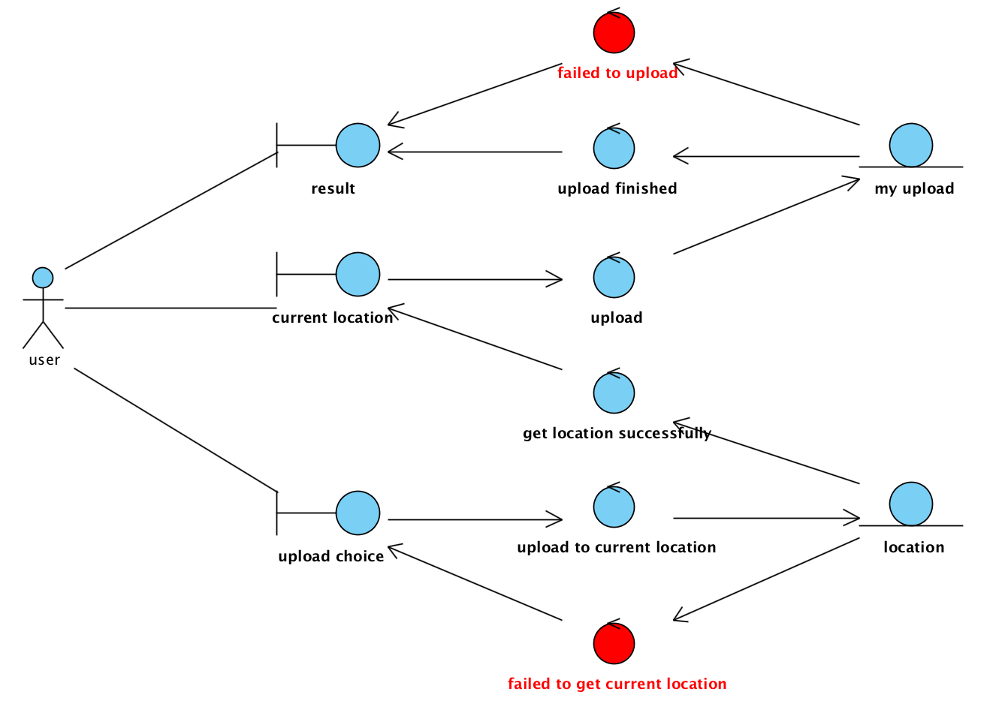

**Use Case: Delete uploaded photos**

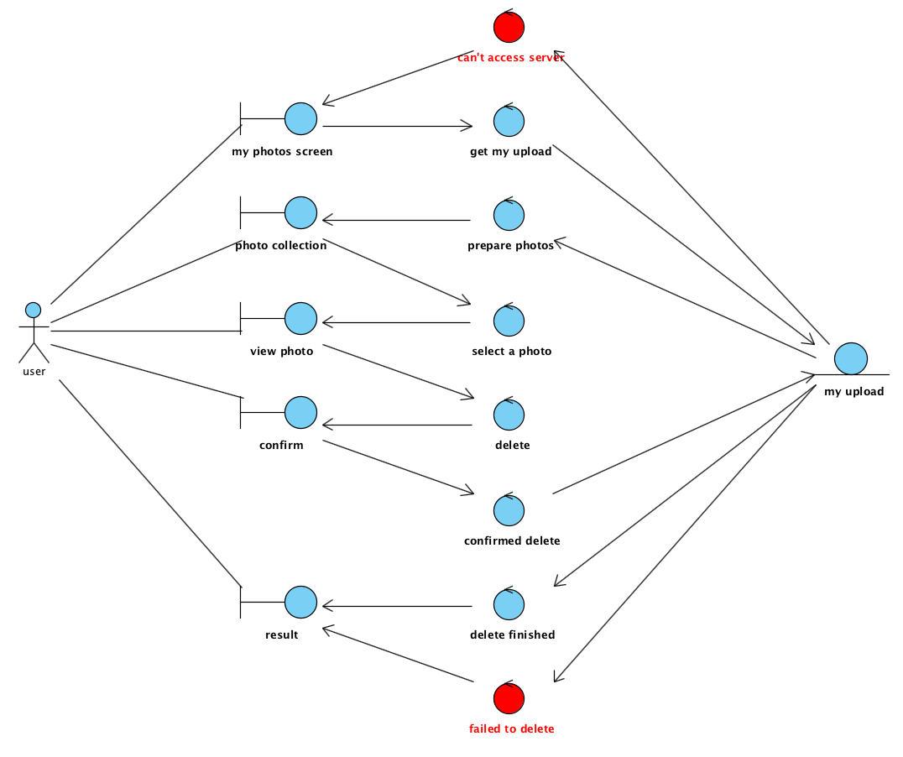

## Search Robustness Diagram

**Use Case: Search by event:**

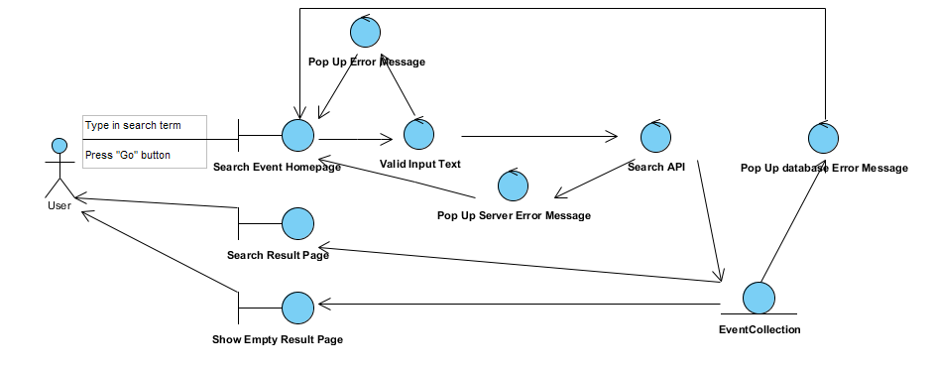

**Use Case: Search by Location:**

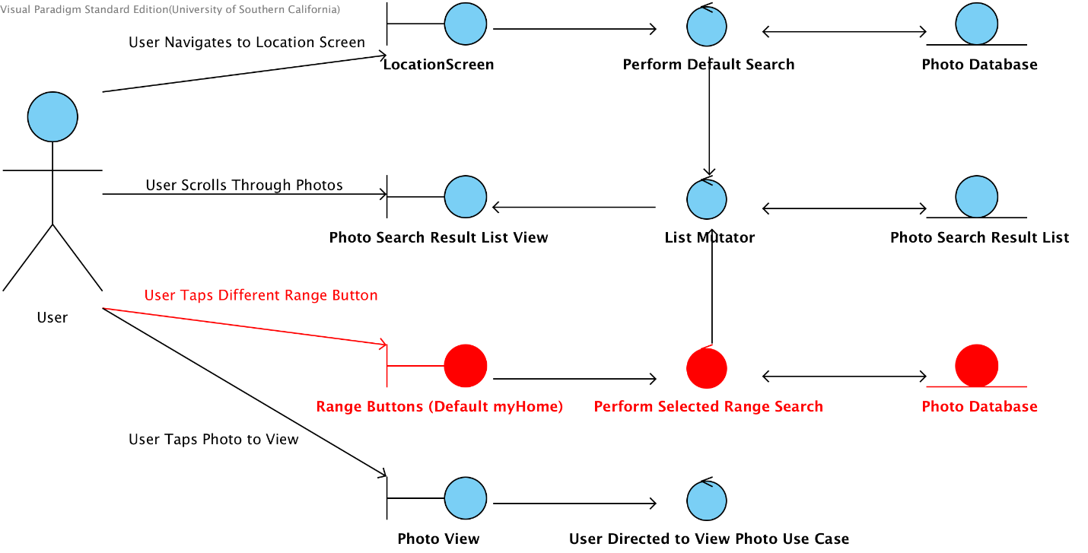

## Profile Robustness Diagram

**Use Case: Create account**

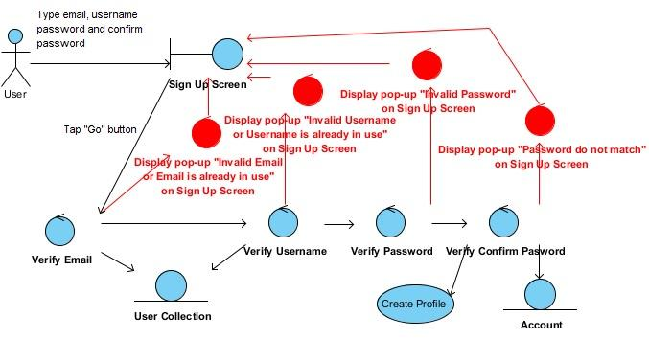

**Use Case: Create profile**

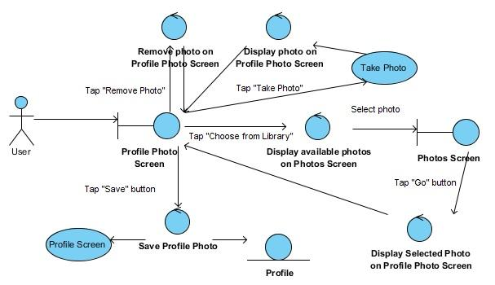

**Use Case: Login to account**

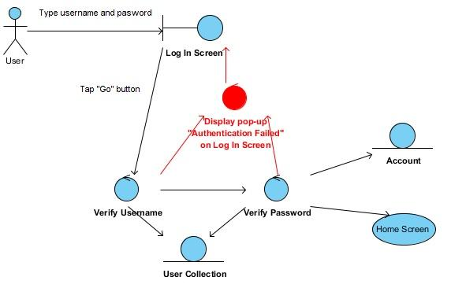

**Use Case: Logout of account**

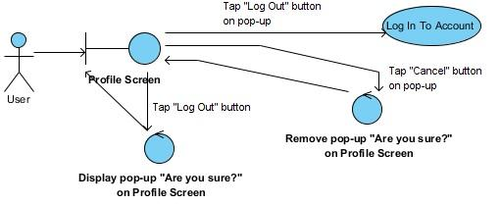

## System & Administrator Robustness Diagram

**Use Case: Admin searches for photo by user**

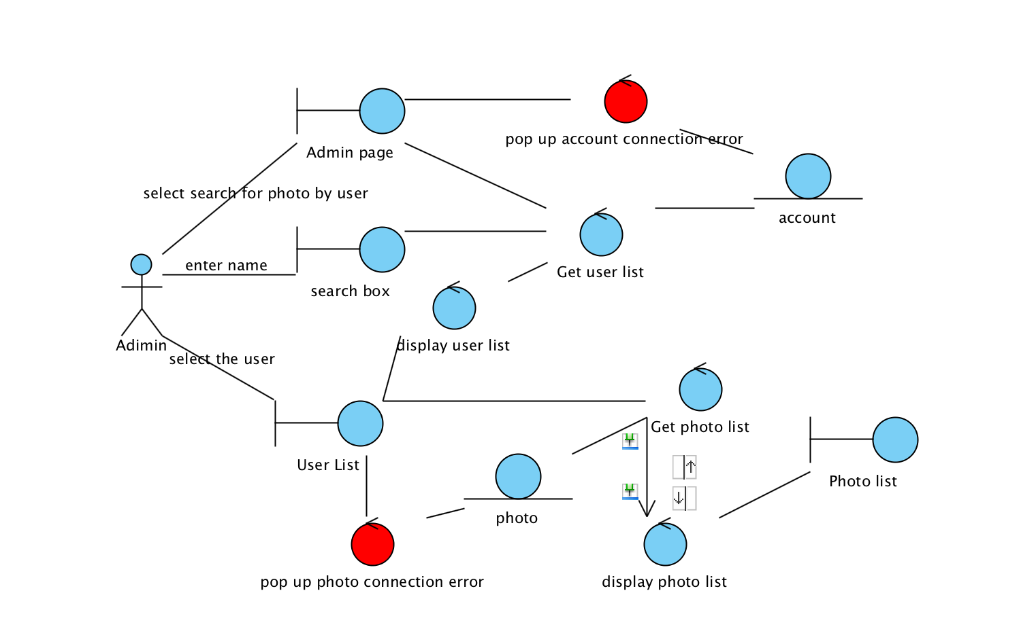

**Use Case: Admin searches for photo by event**

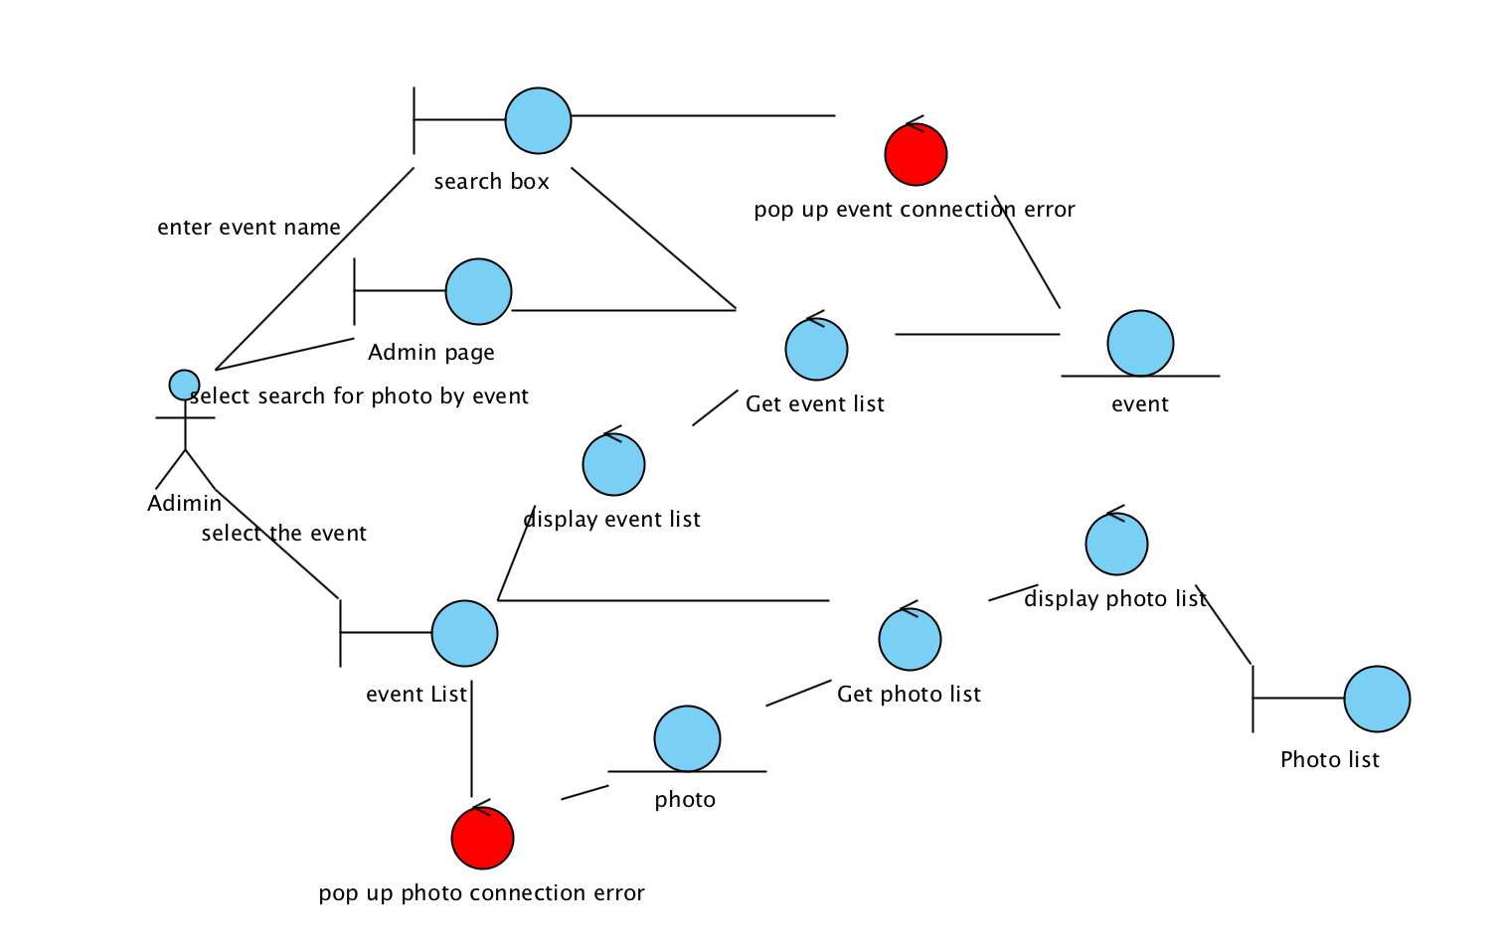

**Use Case: Admin deletes photo**

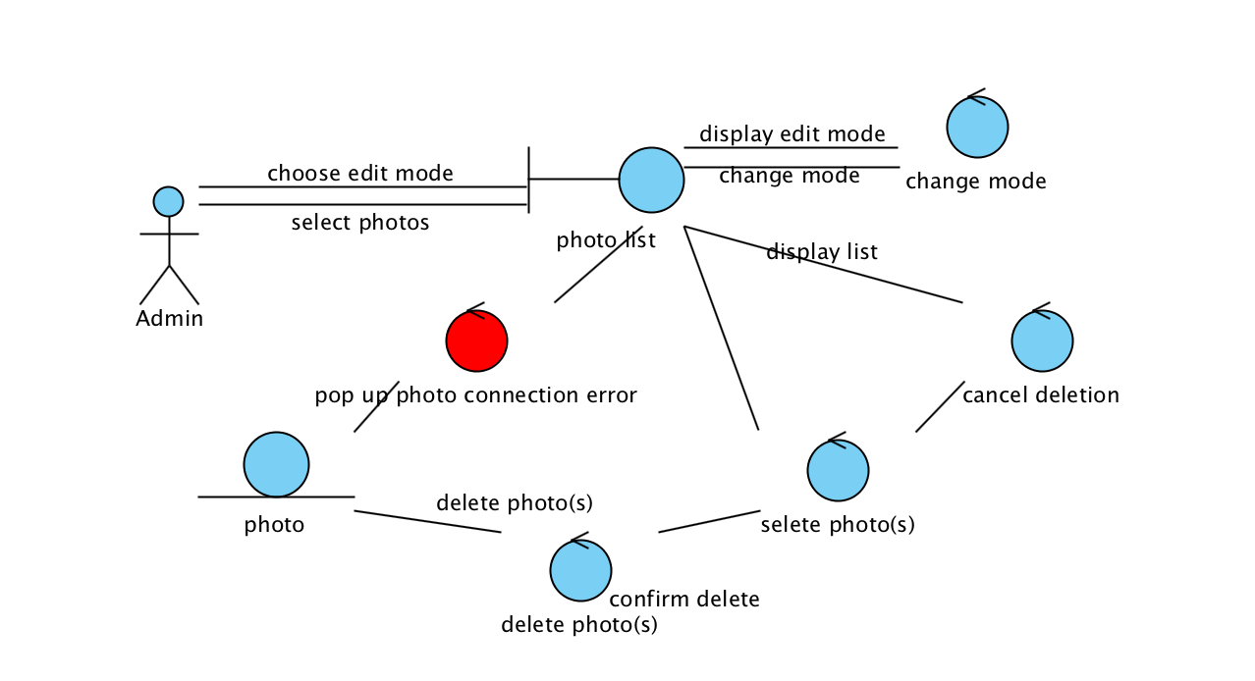

**Use Case: Automatic deletion**

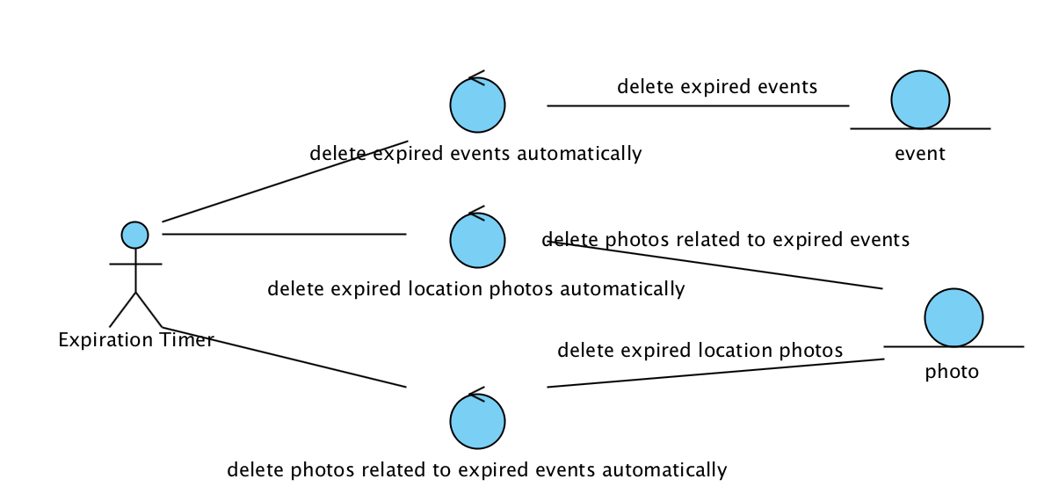

# Class diagram

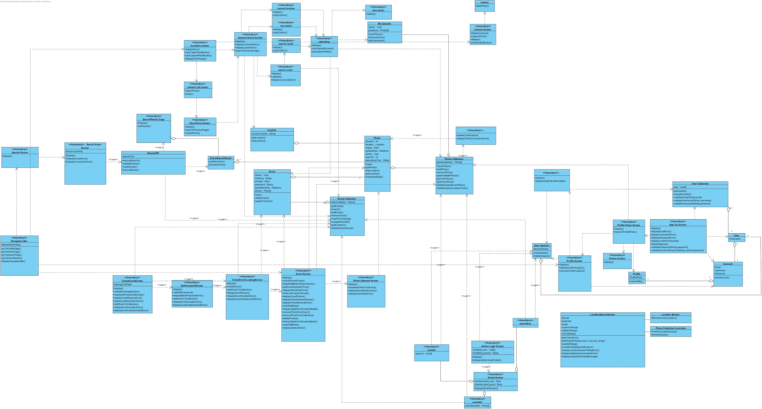

# Sequence Diagrams

## Navigation Sequence Diagram

**Use Case: Navigate between screen**

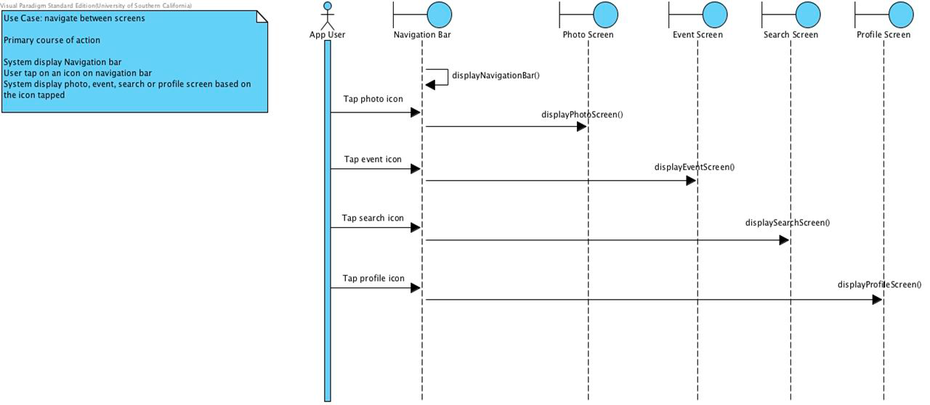

## Event Sequence Diagram

**Use Case: Create a pubic event**

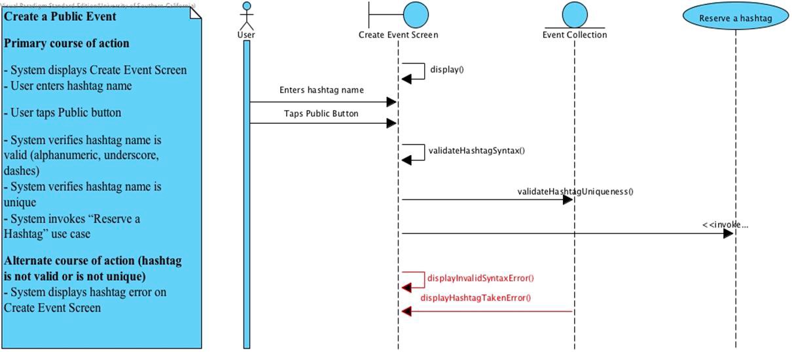

**Use Case: Create a private event**

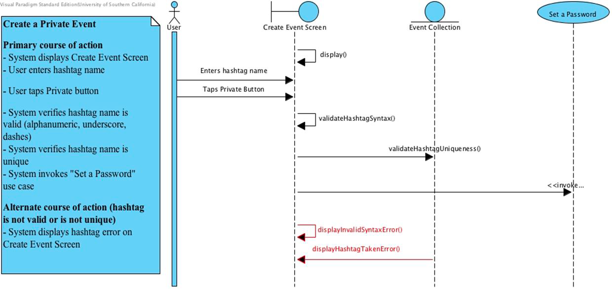

**Use Case: Set a password**

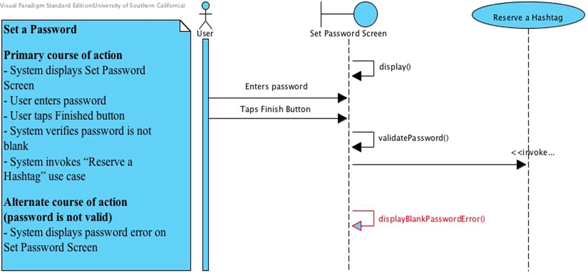

**Use Case: Reserve a hashtag**

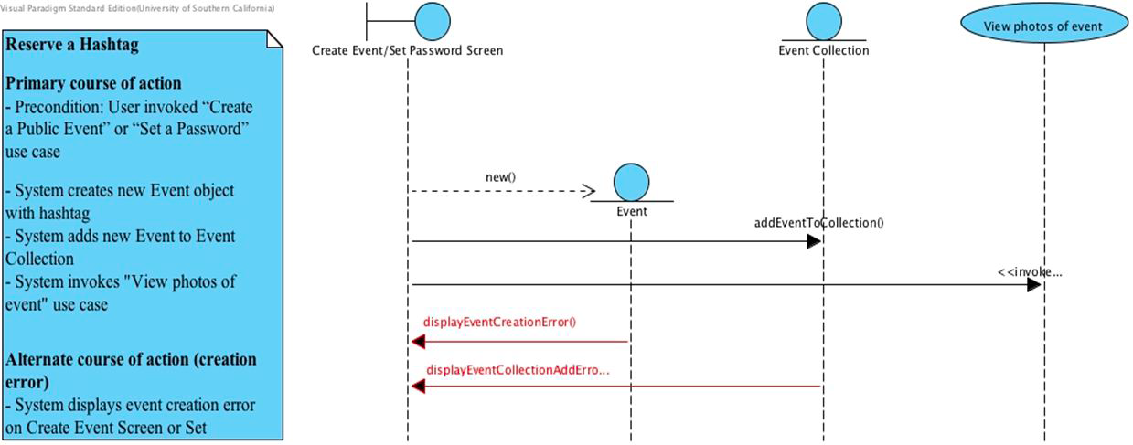

**Use Case: View photos of event/View photos of private event with password**

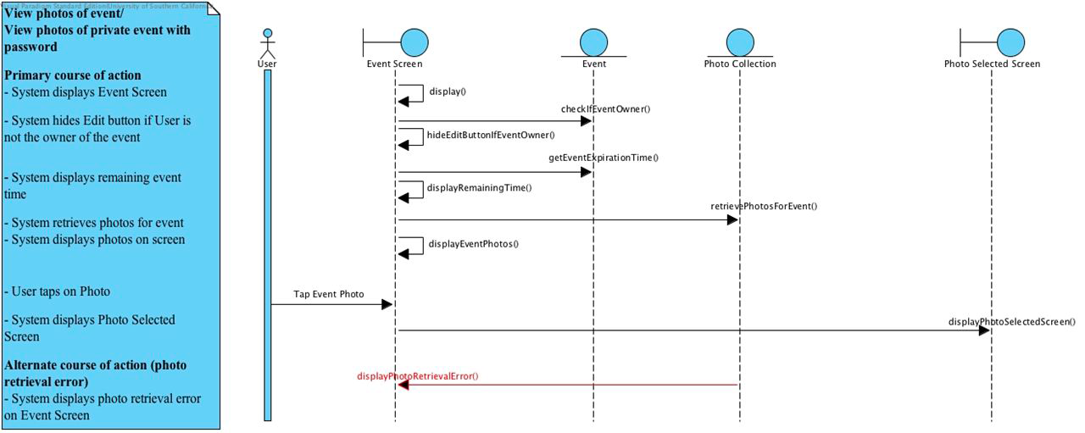

**Use Case: Download photos to device**

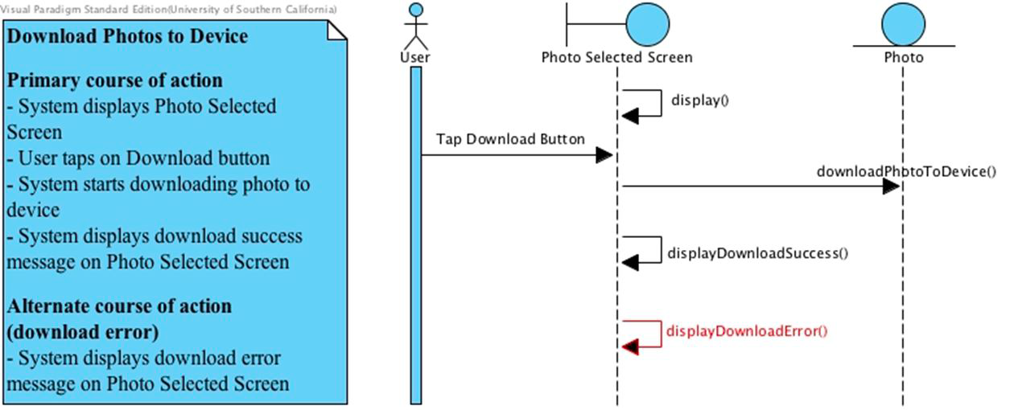

**Use Case: Delete photos in event if owner**

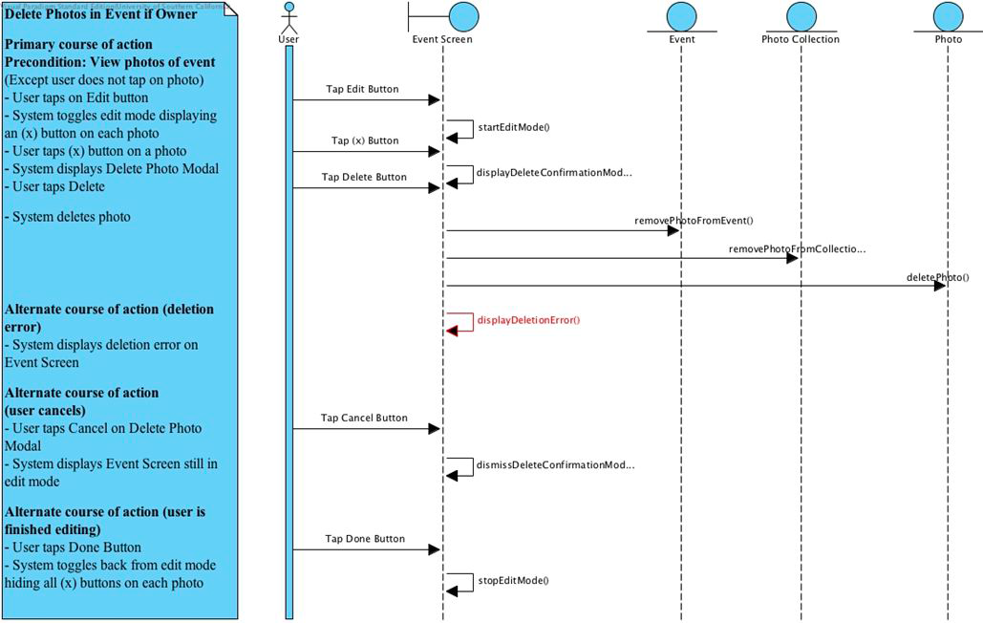

**Use Case: View joined events**

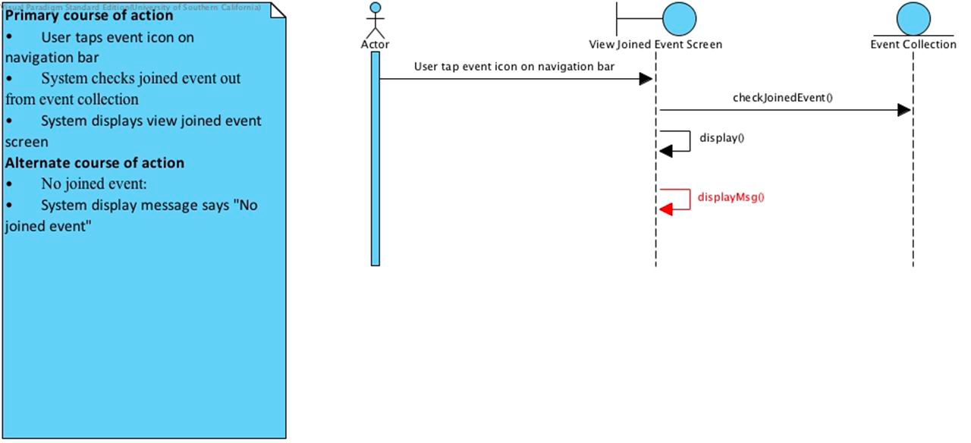

## Photo Sequence Diagram

**Use Case: Take a photo**

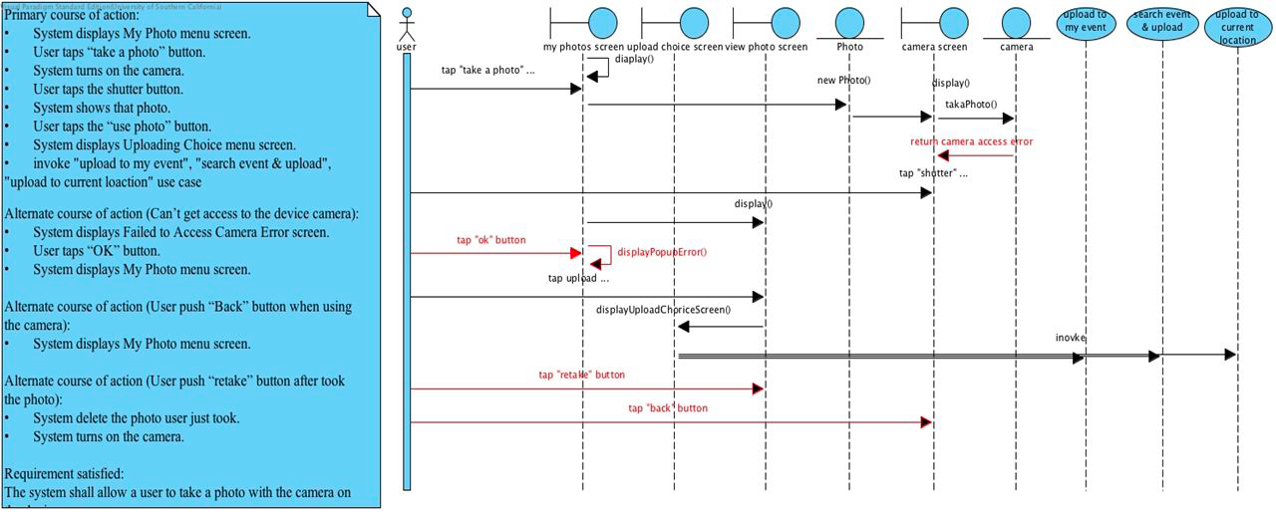

**Use Case: View photos on devices**

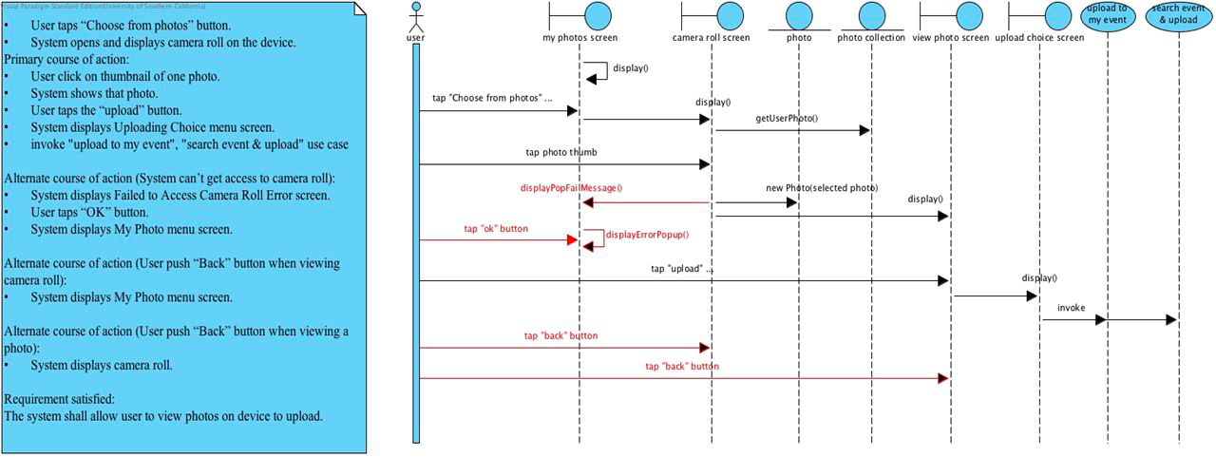

**Use Case: Open my event for upload**

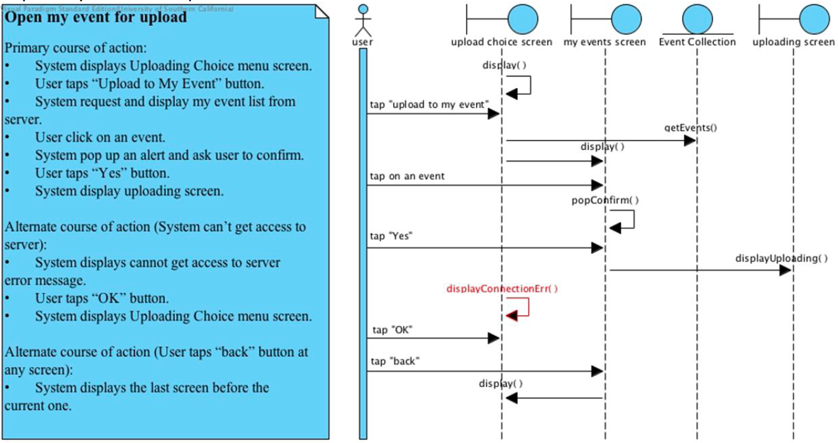

**Use Case: Search event for upload**

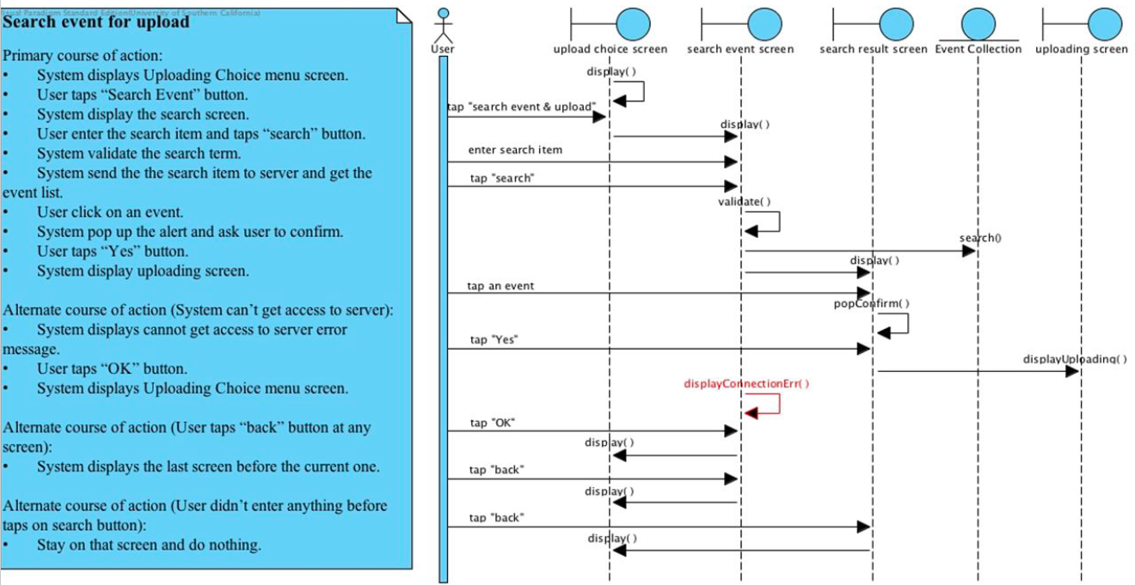

**Use Case: Upload to event**

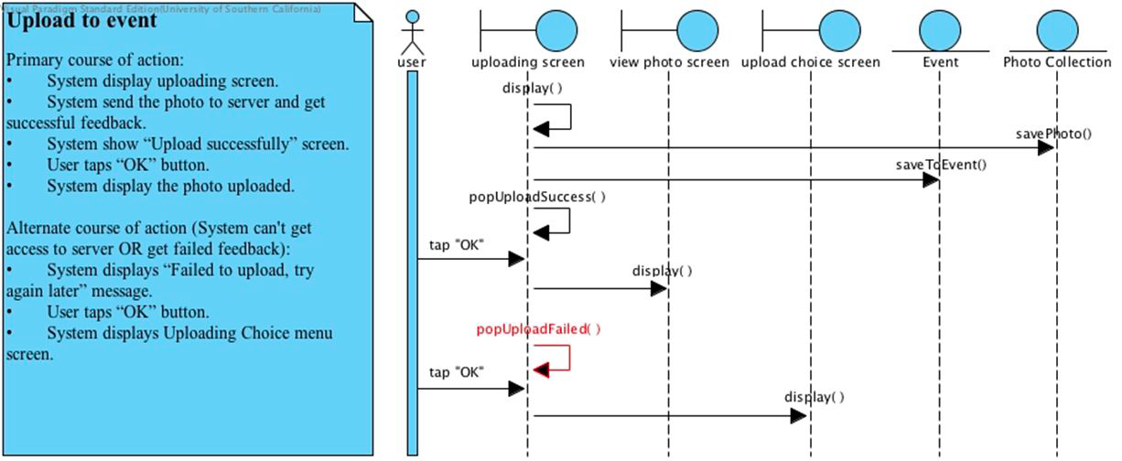

**Use Case: Upload to location after taking photo**

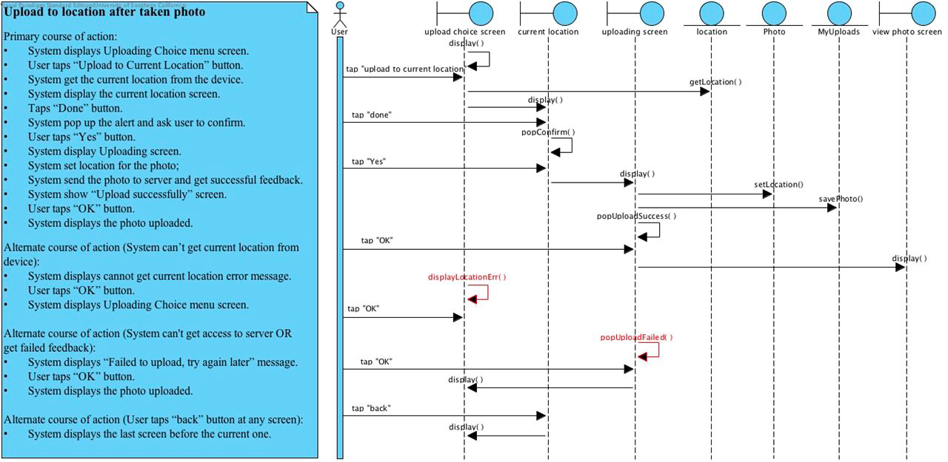

**Use Case: Delete uploaded photos**

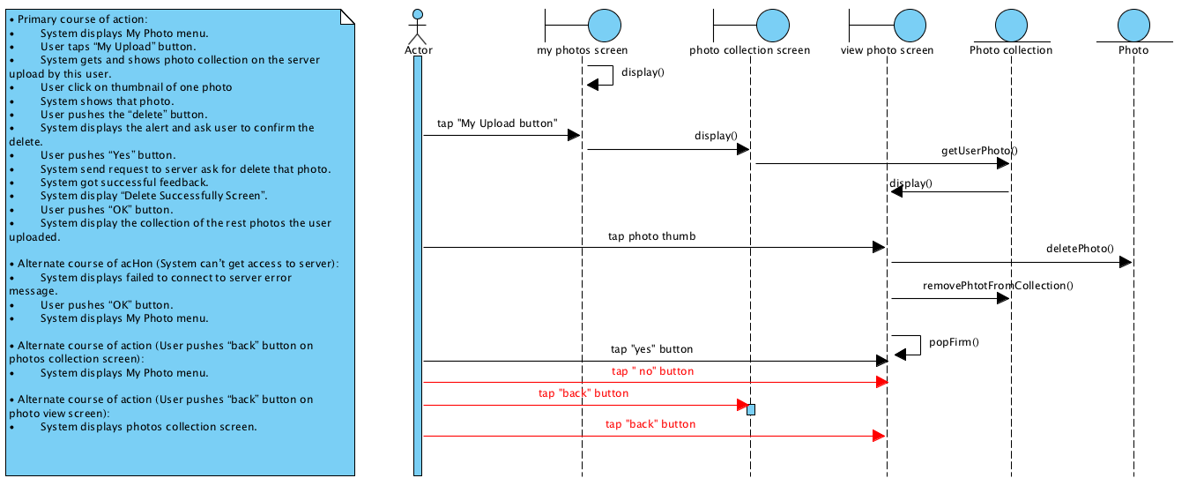

## Search Sequence Diagram

**Use Case: Search event**

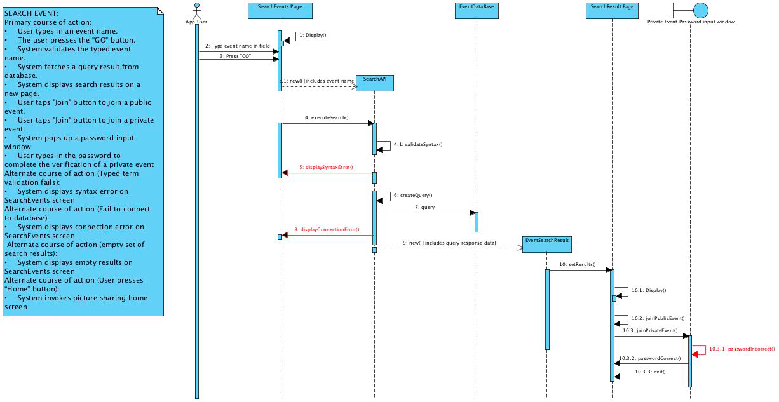

**Use Case: Search photos by location - Primary course of action**

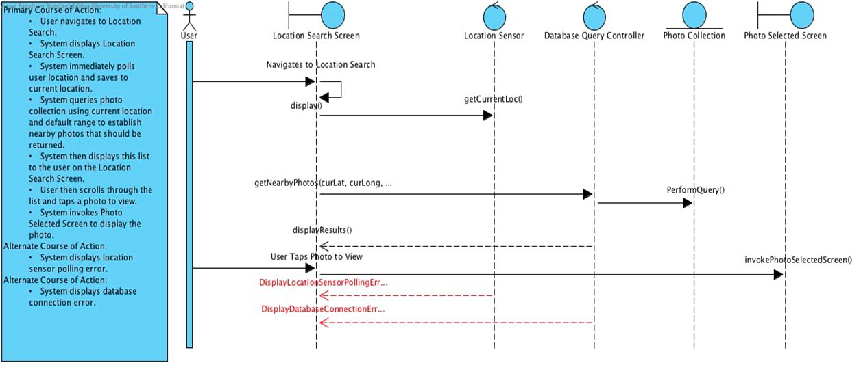

**Use Case: Search photos by location - Alternate course of action**

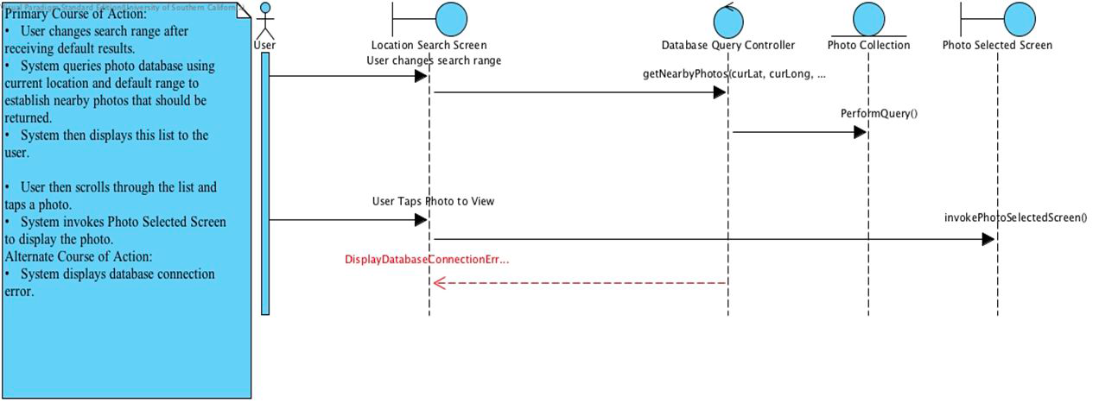

## Profile Sequence Diagram

**Use Case: Create account**

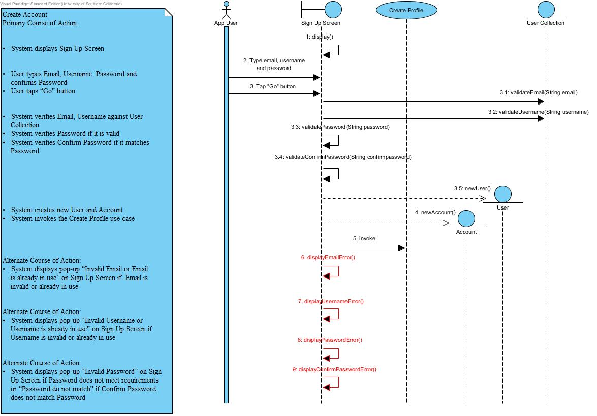

**Use Case: Create profile**

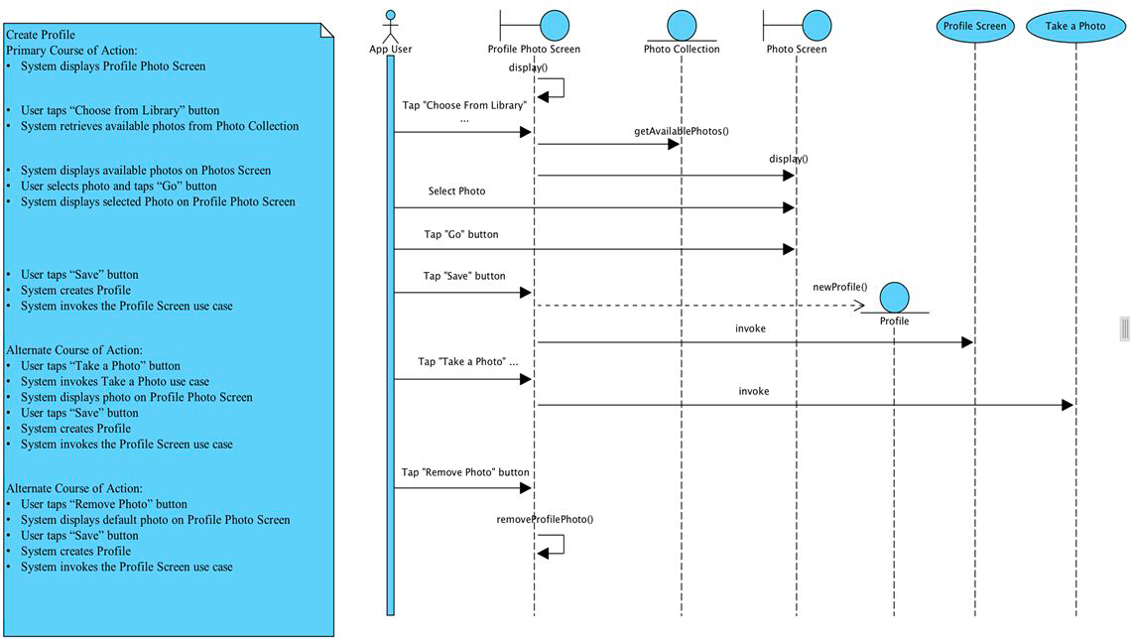

**Use Case: Login to account**

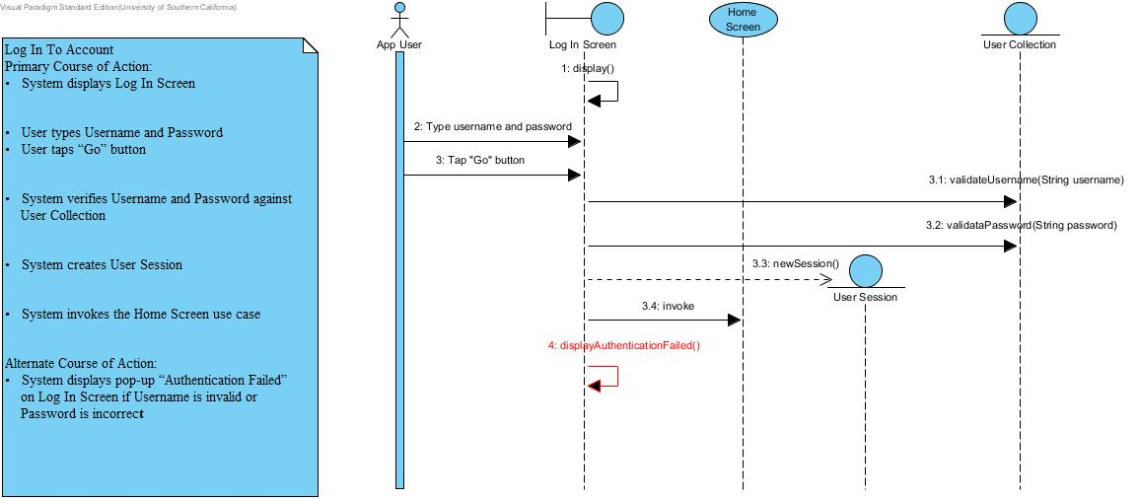

**Use Case: Logout of account**

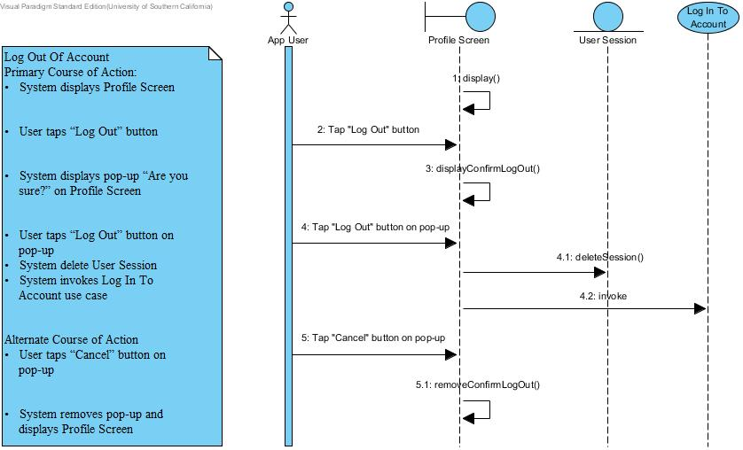

## System & Administrator Sequence Diagram

**Use Case: Admin login**

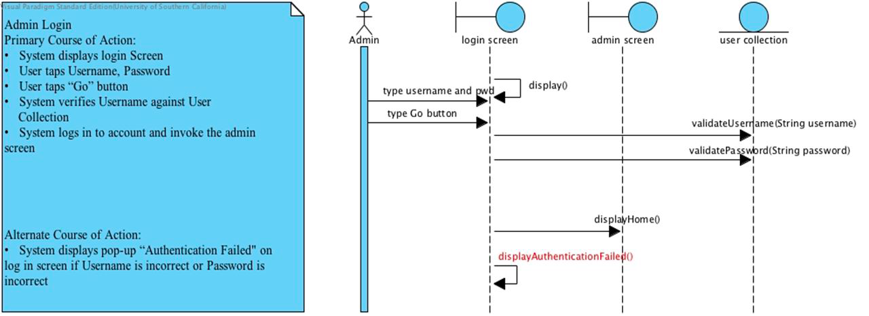

**Use Case: Search for photo by user**

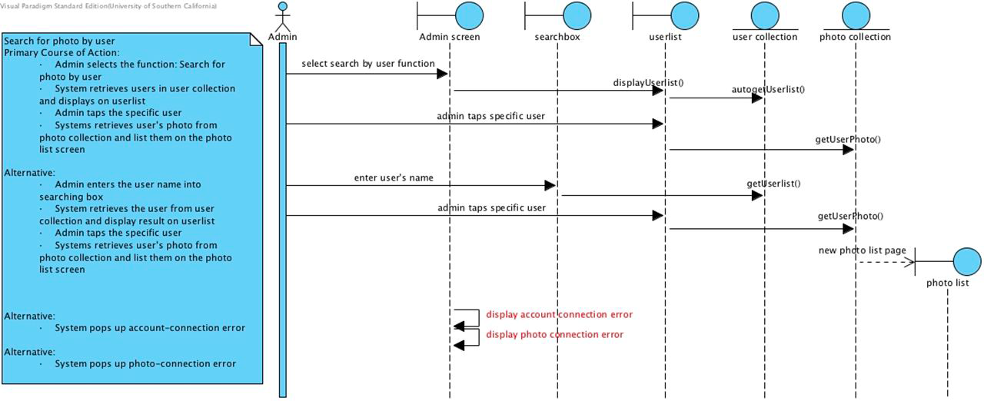

**Use Case: Search for photo by event**

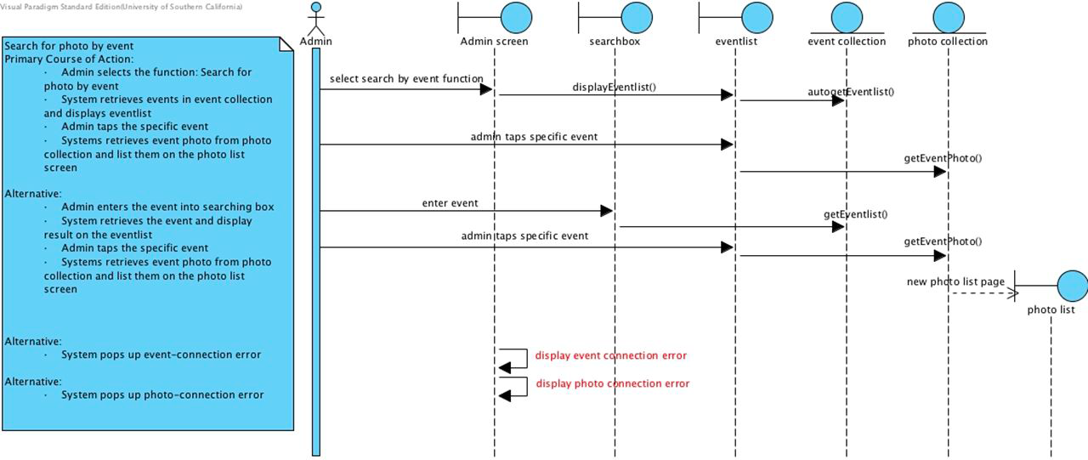

**Use Case: Admin delete photo**

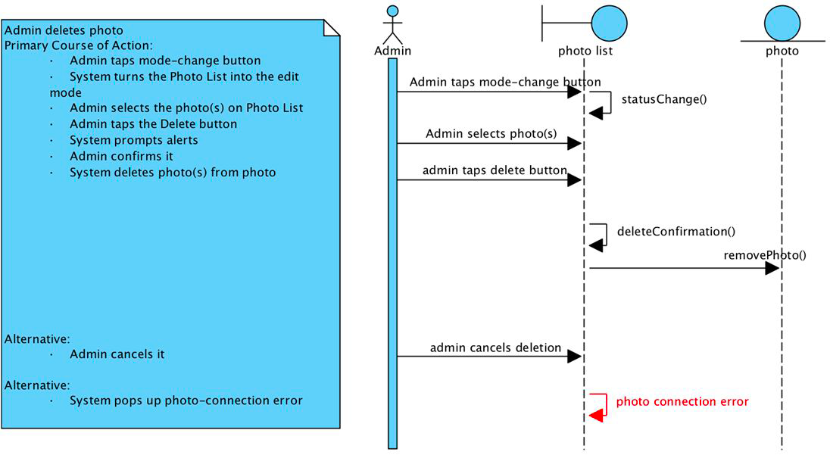

**Use Case: Auto-expiration**

